CHAROTAR UNIVERSITY OF SCIENCE & TECHNOLOGY
FACULTY OF TECHNOLOGY AND ENGINEERING
U & P U. Patel Department of Computer Engineering

Subject Name: Data Structures & Algorithms Semester : IV
Subject Code: CE245 Academic year: 2017-18

Practical List
Sr. No | Aim Of the Practical
1. | PRACTICAL 1  Given an array of integers, find out the occurrences of a particular number.  Assume two scenarios: 1. Array is unsorted  2. Array is sorted  Exercise:  1.1 Let say you are a cashier in PQR Bank, people come to you when they want to withdraw money from their respective account. People have to come with their ADHAR CARD Photocopy. Prakash came and withdrew money from his account, of course by submitting adhar card photocopy, but on the second day he felt that submitted adhar card photocopy was not his, but adhar card no. he knew, which is (89891245).  i) How will you find that particular adhar card? (Suppose total 15 people withdrew their money on that day). Assume there is no fix pattern in all adhar cards. )  ii) How will you find that particular adhar card? (Suppose total 20 people withdrew their money on that day). Assume there is a pattern in all adhar cards, all are in ascending order (89891235 To 89891254).  1) #include<iostream>  using namespace std;  int main()  {  long int a[15]={89291245,81891245,89854245,89895245,89891255,89841245,89881245,89871245,89291245,82891245,89891545,89891245,89841245,89791245,89891545};  long int founding;  cin>>founding;  int flag=0;  for(int i=0;i<15;i++)  {  if(a[i]==founding)  {  cout<<"found at "<<i;  flag=1;  }  }  if(flag==0)  {  cout<<"item not found!!";  }  }  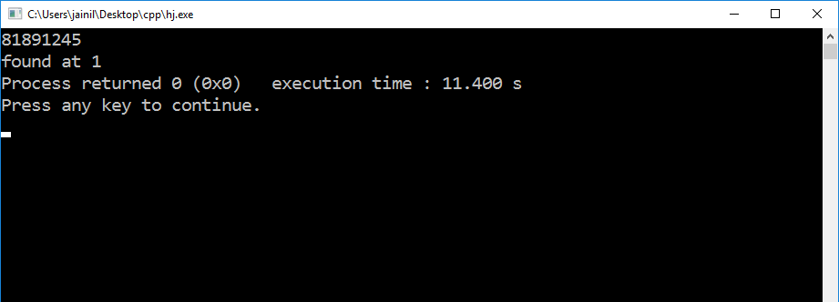  Complexity O(n)=: n²  2) #include<iostream>  using namespace std;  int main()  {  long int a[20];  int lower=0;  int upper=20;  long int founding;  int flag=0;  int j=0;  cin>>founding;  for(long int i=89891235;i<=89891254;i++)  {  a[j]=i;  j++;  }  while((lower<=upper)&&flag==0)  {  int middle=(lower+upper)/2;  if(a[middle]==founding)  {  cout<<"found at "<<middle<<" index";  flag=1;  }  else if((a[middle]-founding)<0)  {  lower=middle+1;  }  else{  upper=middle-1;  }  }  if(flag==0)  {  cout<<("item not found");  }  }  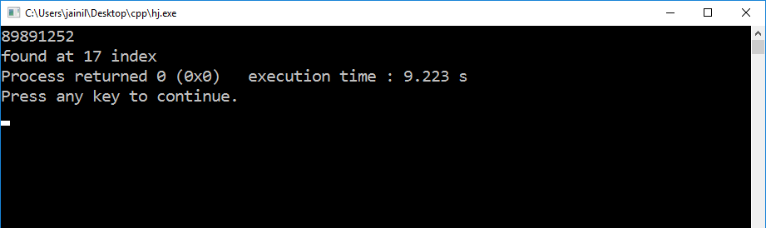  Complexity O(n)=: n²
2 | PRACTICAL 2  Write a program to sort the following two lists using Selection and Insertion sort. Also, Count the number of comparisons and exchanges for both inputs.  Input1: 23,34,56,90,78,100,123,234  Input2: 34,54,12,10,67,45,55,88,10  Exercise:  2.1 Mark purchased Books from books store of standard 1 to 7. He purchased 4 books for each standard(for std.1 books are 1.1,1.2,1.3,1.4 and for std. 2 books are 2.1,2.2,2.3,2.4 and so on..). When he reached home, he opens the bag and sees that all the books got mixed. So, how he will sort all the books, according to the standards and their preference in that particular standard. (ex. : preference in std. 1 is 1.1<1.2<1.3)  2.2 Implement the function shift_element() which takes as input the index of an array element that has been determined to be out of order. The function shifts the element towards the front of the array, repeatedly swapping the preceding element until the out-of-order element is in the proper location. Print the updated list.  1)//input 1 insertion sort.  #include<iostream>  using namespace std;  int main()  {  int comparision=0;  int exchange=0;  int arr[10]={23,34,56,90,78,100,123,234};  int n=8;  int i, key, j;  for (i = 1; i < n; i++)  {  comparision++;  key = arr[i];  j = i-1;  while (j >= 0 && arr[j] > key)  {  comparision++;  comparision++;  arr[j+1] = arr[j];  j = j-1;  exchange++;  }  arr[j+1] = key;  }  for(i=0;i<8;i++)  {  cout<<arr[i]<<",";  }  cout<<"\ncomparision="<<comparision<<" exchange="<<exchange;  }  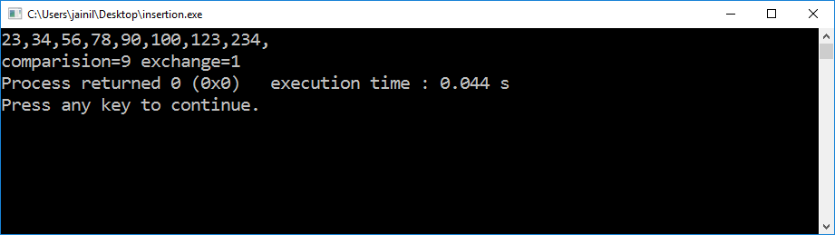  Complexity O(n)=: n²  2)//input 1 selection sort.  #include<iostream>  using namespace std;  int main()  {  int comparision=0;  int exchange=0;  int arr[10]={23,34,56,90,78,100,123,234};  int n=8;  int i, j, min,temp;  for (i = 0; i < n-1; i++)  {  comparision++;  min = i;  for (j = i+1; j < n; j++)  {  comparision++;  if (arr[j] < arr[min])  {min = j; comparision++;}}  temp=arr[i];  arr[i]=arr[min];  arr[min]=temp;  exchange++;  }  for(i=0;i<8;i++)  {  cout<<arr[i]<<",";  }  cout<<"\ncomparision="<<comparision<<" exchange="<<exchange;  }  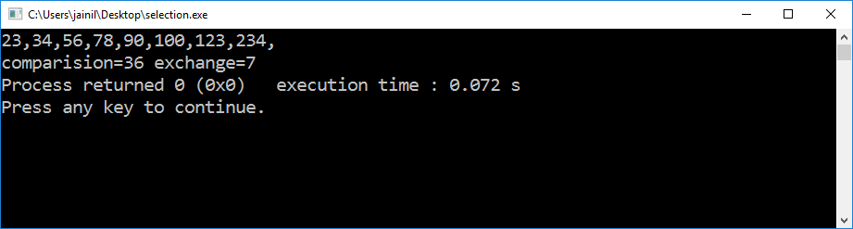  Complexity O(n)=: n²  3)//input 2 insertion sort  #include<iostream>  using namespace std;  int main()  {  int comparision=0;  int exchange=0;  int arr[10]={34,54,12,10,67,45,55,88,10};  int n=8;  int i, key, j;  for (i = 1; i < n; i++)  {  comparision++;  key = arr[i];  j = i-1;  while (j >= 0 && arr[j] > key)  {  comparision++;  comparision++;  arr[j+1] = arr[j];  j = j-1;  exchange++;  }  arr[j+1] = key;  }  for(i=0;i<8;i++)  {  cout<<arr[i]<<",";  }  cout<<"\ncomparision="<<comparision<<" exchange="<<exchange;  }  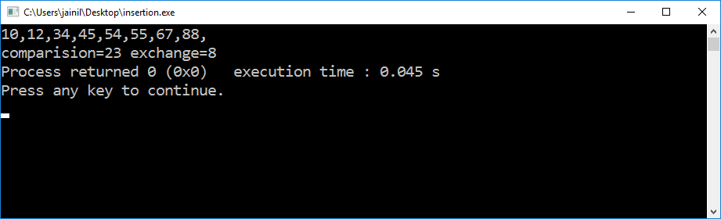  Complexity O(n)=: n²  4)//input 2 selection sort  #include<iostream>  using namespace std;  int main()  {  int comparision=0;  int exchange=0;  int arr[10]={34,54,12,10,67,45,55,88,10};  int n=8;  int i, j, min,temp;  for (i = 0; i < n-1; i++)  {  comparision++;  min = i;  for (j = i+1; j < n; j++)  {  comparision++;  if (arr[j] < arr[min])  {min = j; comparision++;}}  temp=arr[i];  arr[i]=arr[min];  arr[min]=temp;  exchange++;  }  for(i=0;i<8;i++)  {  cout<<arr[i]<<",";  }  cout<<"\ncomparision="<<comparision<<" exchange="<<exchange;  }  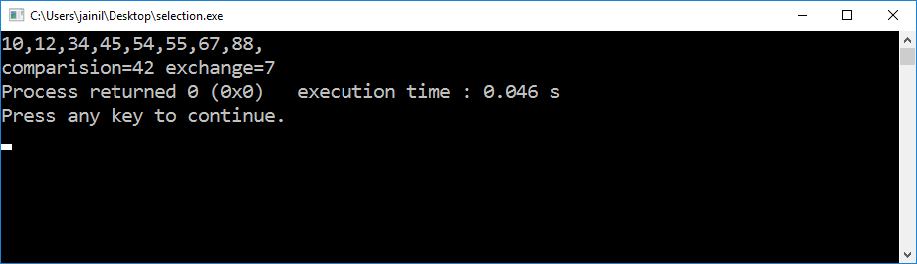  Complexity O(n)=: n²  2.1) /* Mark purchased Books from books store of standard 1 to 7. He purchased 4 books for each standard(for std.1 books are 1.1,1.2,1.3,1.4 and for std. 2 books are 2.1,2.2,2.3,2.4 and so on..). When he reached home, he opens the bag and sees that all the books got mixed. So, how he will sort all the books, according to the standards and their preference in that particular standard. (ex. : preference in std. 1 is 1.1<1.2<1.3) */  #include<iostream>  using namespace std;  int main()  {  float arr[28]={1.1,1.3,1.2,1.4,2.1,2.2,2.3,2.4,3.2,3.1,3.3,3.4,4.3,4.2,4.1,4.4,5.2,5.1,5.3,5.4,6.1,6.3,6.1,6.2,7.1,7.3,7.4,7.2};  int n=28;  float temp;  int j,i,min;  for (i = 0; i < n-1; i++)  {  min = i;  for (j = i+1; j < n; j++)  {  if (arr[j] < arr[min])  {min = j; }}  temp=arr[i];  arr[i]=arr[min];  arr[min]=temp;  }  for(i=0;i<n;i++)  {  cout<<arr[i]<<",";  }  }  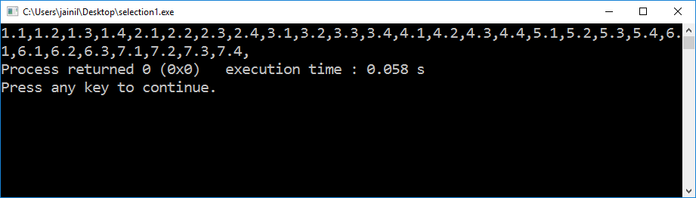  Complexity O(n)=: n²  2.2) /*Implement the function shift_element() which takes as input the index of an array element that has been determined to be out of order.  The function shifts the element towards the front of the array, repeatedly swapping the preceding element until the out-of-order element is in the proper location.  Print the updated list.*/  #include<iostream>  using namespace std;  int arr[10]={34,54,12,10,67,45,55,88,10};  void shiftelement(int j)  {  int i=j+1;  int key=arr[i];  while (j >= 0 && arr[j] > key)  {  arr[j+1] = arr[j];  j = j-1;  }  arr[j+1] = key;  }  int main()  {  int n=8;  int i, key, j;  for (i = 2; i < n-1; i++)  {  shiftelement(i);  }  for(i=0;i<8;i++)  {  cout<<arr[i]<<",";  }  }  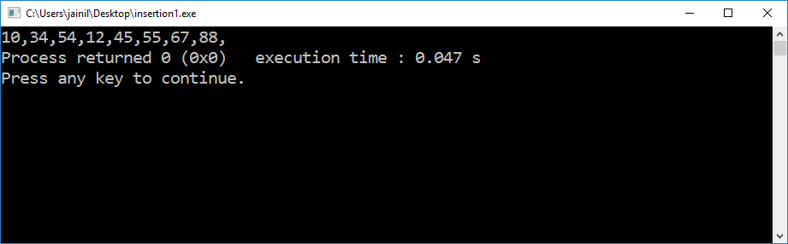  Complexity O(n)=: n²
3 | PRACTICAL 3  Implement a menu driven program that performs following sorting algorithms.  3.1 QUICK SORT that arranges in ascending order  3.2 MERGE SORT that arranges in descending order  3.1)quick sort  #include<iostream>  using namespace std;  int a[]={2,6,7,1,4,2};  int temp;  int partition(int a[],int p,int r)  {  int x=a[r];  int i=p-1;  for(int j=p;j<r;j++)  {  if(a[j]<=x)  {  i++;  int temp=a[j];  a[j]=a[i];  a[i]=temp;  }  }  int temp=a[r];  a[r]=a[i+1];  a[i+1]=temp;  return (i+1);  }  int quicksort(int a[],int p,int r)  {  if(p<r)  {  int q;  q=partition(a,p,r);  quicksort(a,p,q-1);  quicksort(a,q+1,r);  }  }  int main()  {  quicksort(a,0,5);  for(int i=0;i<=5;i++)  {  cout<<a[i]<<",";  }  }  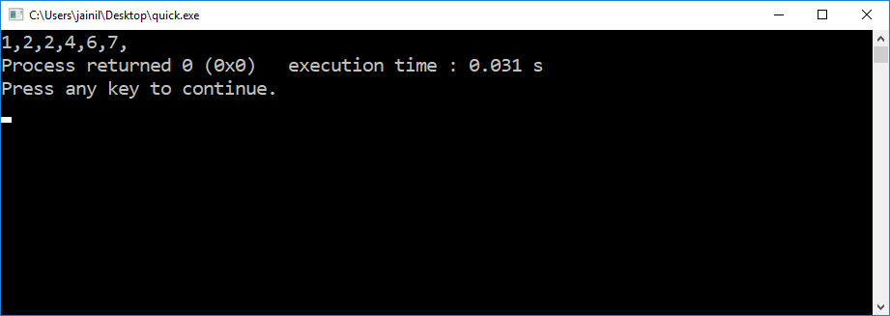  Complexity O(n)=: n²  (3.2)merge sort  #include<iostream>  #include<cmath>  using namespace std;  int simplemerge(int *k,int first,int second,int third)  {  int i=first;  int j=second+1;  int l=first;  int temp[5000];  while((i<=second)&&j<=third)  {  if(k[i]<k[j])  {  temp[l]=k[i];  l=l++;  i=i++;  }  else  {  temp[l]=k[j];  l=l++;  j=j++;  }  }  while(i<=second)  {  temp[l]=k[i];  l=l++;  i=i++;  }  while(j<=third)  {  temp[l]=k[j];  l=l++;  j=j++;  }  for(i=first;i<l;i++)  {  k[i]=temp[i];  }  return 0;  }  int twowaymerge(int *k,int start,int finish)  {  int middle;  if(start<finish)  {  middle=(start+finish)/2;  twowaymerge(k,start,middle);  twowaymerge(k,middle+1,finish);  simplemerge(k,start,middle,finish);  }  return 0;  }  int main()  {  int a[10]={5,2,4,9,8,7,3,1,6,10};  twowaymerge(a,0,9);  for(int i=0;i<10;i++)  {  cout<<a[i]<<" ";  }  }  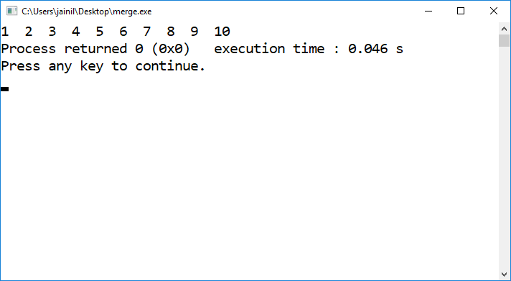  PRACTICAL 4  4.1. Implement a program that enters Infix expression, verify validity and convert it into Postfix expression (if valid).  #include<iostream>  #include<stdio.h>  #include<stack>  using namespace std;  class stackk  {  public:  int n=500;  stackk()  {  n=500;  }  stackk(int a)  {  n=a;  }  char data[500];  int topp=-1;  void push(char a)  {  if (topp==n-1)  {  cout<<"overflow occured";  }  else  {  topp++;  data[topp]=a;  }  }  char pop()  {  if(topp==-1)  {  cout<<"underflow occured";  return -1;  }  else  {  topp--;  return data[topp+1];  }  }  char top()  {  return(data[topp]);  }  };  int prec(char c)  {  if(c == '^')  return 3;  else if(c == '*' || c == '/')  return 2;  else if(c == '+' || c == '-')  return 1;  else  return -1;  }  void infixToPostfix(string s)  {  stackk st;  st.push('#');  int l = s.length();  string ns;  for(int i = 0; i < l; i++)  {  if((s[i] >= 'a' && s[i] <= 'z')||(s[i] >= 'A' && s[i] <= 'Z'))  ns+=s[i];  else if(s[i] == '(')  st.push('(');  else if(s[i] == ')')  {  while(st.top() != '#' && st.top() != '(')  {  char c = st.top();  st.pop();  ns += c;  }  if(st.top() == '(')  {  char c = st.top();  st.pop();  }  }  else{  while(st.top() != '#' && prec(s[i]) <= prec(st.top()))  {  char c = st.top();  st.pop();  ns += c;  }  st.push(s[i]);  }  }  while(st.top() != '#')  {  char c = st.top();  st.pop();  ns += c;  }  cout << ns << endl;  }  int main()  {  string exp;  cout<<"enter infix expression \n";  cin>>exp;  infixToPostfix(exp);  return 0;  }  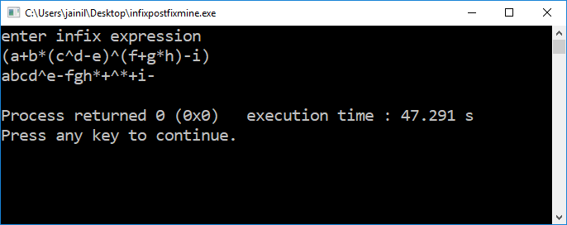  4.2 Implement Tower of Hanoi Problem using Recursion.  #include <iostream>  using namespace std;  int moves(0);  void Hanoi(int m, char a, char b, char c);  void Hanoi(int m, char a, char b, char c){  moves++;  if(m == 1){  cout << "Move disc " << m << " from " << a << " to " << c << endl;  }else{  Hanoi(m-1, a,c,b);  cout << "Move disc " << m << " from " << a << " to " << c << endl;  Hanoi(m-1,b,a,c);  }  }  int main(){  int discs;  cout << "Enter the number of discs: " << endl;  cin >> discs;  Hanoi(discs, 'A', 'B', 'C');  cout << "It took " << moves << " moves. " << endl;  }  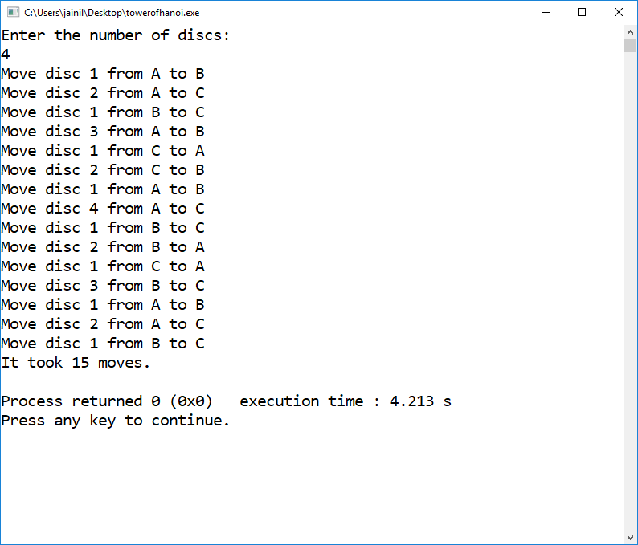  4.3 Write a program that enters valid Postfix expression and evaluate the same.  #include<iostream>  #include <sstream>  #include<string>  #include<math.h>  using namespace std;  class stackk  {  public:  int n=500;  stackk()  {  n=500;  }  stackk(int a)  {  n=a;  }  char data[500];  int top=-1;  void push(int a)  {  if (top==n-1)  {  cout<<"overflow occured";  }  else  {  top++;  data[top]=a;  }  }  int pop()  {  if(top==-1)  {  cout<<"underflow occured";  return -1;  }  else  {  top--;  return data[top+1];  }  }  int peek(int i)  {  if((top-i+1)<=-1)  {  return '&';  }  return(data[top]-i+1);  }  }s;  int mul(int a,int b)  {  return(a*b);  }  int div(int a,int b)  {  return(a/b);  }  int add(int a,int b)  {  return(a+b);  }  int sub(int a,int b)  {  return(a-b);  }  int poww(int a,int b)  {  return(pow(a,b));  }  int main()  {  string s1;int i=0;  cout<<"enter valid string";  cin>>s1;  for(int i=0;i<s1.length();i++)  {  char a=s1[i];  if(!(a=='+'||a=='-'||a=='*'||a=='/'||a=='^'))  {  s.push(a-48);  }  else  {  int aa=s.pop();  int b=s.pop();  int c;  if(a=='+')  {  c=add(b,aa);  }  if(a=='-')  {  c=sub(b,aa);  }  if(a=='/')  {  c=div(b,aa);  }  if(a=='*')  {  c=mul(b,aa);  }  if(a=='^')  {  c=poww(b,aa);  }  s.push(c);  }  }  cout<<"answer is "<<s.pop();  }  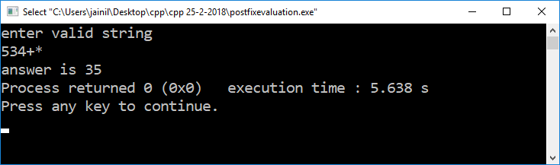  PRACTICAL 5:  Stack  →implement stack data structure  Stack.cpp  #include<iostream>  #include<cstring>  using namespace std;  class stackk  {  public:  int n=500;  stackk()  {  n=500;  }  stackk(int a)  {  n=a;  }  int data[500];  int top=-1;  void push(int a)  {  if (top==n-1)  {  cout<<"overflow occured";  }  else  {  top++;  data[top]=a;  }  }  int pop()  {  if(top==-1)  {  cout<<"underflow occured";  return -1;  }  else  {  top--;  return data[top+1];  }  }  int peek(int i)  {  if((top-i+1)<=-1)  {  cout<<"not found";  }  return(data[top]-i+1);  }  };  int main()  {  stackk a(50);  int choice;  int x;  while(1){  cout<<"1.push \n";  cout<<"2.pop \n";  cin>>choice;  if(choice==1)  {  cout<<"enter data:";  cin>>x;  a.push(x);  }  if(choice==2)  {  cout<<a.pop()<<"\n";  }}  }  OUTPUT:  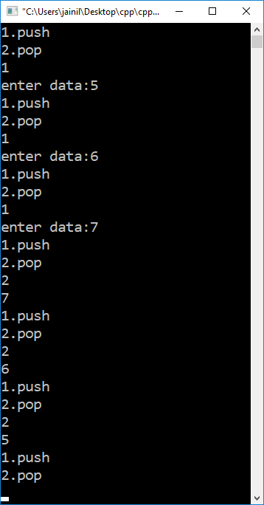  Aim: The Passport Seva Kendra consist 3 zones to scrutinize the passport applications (each and every person must pass through all three zone, known as A, B and C). First, 5 people enter in the queue of zone A, after some time 3 people have completed zone A and enter in the queue of zone B where 2 people already there in the queue. After some time 4 people have completed zone B and enter in the queue of zone C where 3 people already there in the queue. After some time 5 people completed their application scrutiny process and came out from Passport Seva Kendra. Print the contents of all three queues. (maximum 5 members can stand in any queue)  #include<iostream>  #include <sstream>  #include<string>  #include<math.h>  using namespace std;  class q  {  public:  int f=-1;  int r=-1;  char a[50];  void anque(char x)  {  if(r!=50){  if(f==-1)  {  f=0;  }  r++;  a[r]=x;  }  else  {  cout<<"overflow";  }  }  char dequee()  {  if(f==r+1)  {  f=-1;  r=-1;  return '/';  cout<<"underflow occured \n";  }  else  {  f++;  return a[f-1];  }  }  };  int main()  {  q a;  q b;  q c;  a.anque('1');  a.anque('2');  a.anque('3');  a.anque('4');  a.anque('5');  b.anque('x');  b.anque('x');  c.anque('x');  c.anque('x');  c.anque('x');  for(int i=0;i<3;i++)  {  b.anque(a.dequee());  }  for(int i=0;i<4;i++)  {  c.anque(b.dequee());  }  for(int i=0;i<5;i++)  {  c.dequee();  }  char d;  d=a.dequee();  cout<<"\n queue a :\n";  while(d!='/')  {  cout<<d<<" ";  d=a.dequee();  }  d=b.dequee();  cout<<"\n queue b :\n";  while(d!='/')  {  cout<<d<<" ";  d=b.dequee();  }  d=c.dequee();  cout<<"\n queue c :\n";  while(d!='/')  {  cout<<d<<" ";  d=c.dequee();  }  }  OUTPUT:  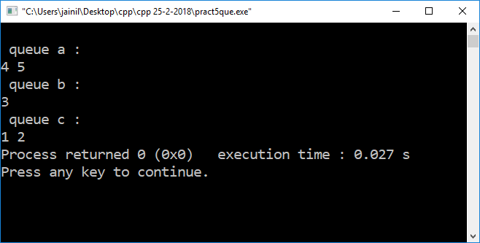  PRACTICAL 6  Write a program to implement Circular Queue with all operations. Check the queue contents and conditions with different combinations of insert and delete operations. Show the content of circular queue with front and rear pointer after each operation. Initially, the queue is empty. The size of the queue is 5. The sequence of operation given below:  • Insert 22, 25, 60, 90  • Delete  • Insert 100, 200, 300  • Delete  • Delete  • Delete  #include<iostream>  #include <sstream>  #include<string>  #include<math.h>  #include<stdio.h>  using namespace std;  class cirqularqueue  {  public:  int f=-1;  int r=-1;  int a[5];  void anque(int x)  {  if((f==0&&r==4)||f==(r+1))  {  cout<<"overflow occured \n";  }  else if(f==-1)  {  f++;  r++;  a[r]=x;  }  else if(r==4&&f!=0)  {  r=0;  a[r]=x;  }  else{  r++;  a[r]=x;}  }  int dequee()  {  if((f>r)&&f==4)  {  f=0;  }  if(f==r)  {  int p=f;  f=-1;  r=-1;  return(a[p]);  }  else  {  f++;  return a[f-1];  }  if(f==-1&&r==-1)  {  cout<<"underflow occured \n";  return(0);  }  }  void display()  {  int i;  printf("\n");  if (f> r)  {  for (i = f; i < 5; i++)  {  printf("%d ", a[i]);  }  for (i = 0; i <= r; i++)  printf("%d ", a[i]);  }  else  {  for (i = f; i <= r; i++)  printf("%d ", a[i]);  }  cout<<"front is at "<<f<<" and rear is at "<<r<<"\n";  }  }qq;  int main()  {  int x;  while(1)  {  cout<<"enter 1 for enqueue"<<"\n";  cout<<"enter 2 for dequeue"<<"\n";  cout<<"enter 3 for display"<<"\n";  cin>>x;  if(x==1)  {  cout<<"enter integer \n";  int c;  cin>>c;  qq.anque(c);  }  if(x==2)  {  cout<<qq.dequee()<<" returned \n";  }  if(x==3)  {  qq.display();  }  }  }  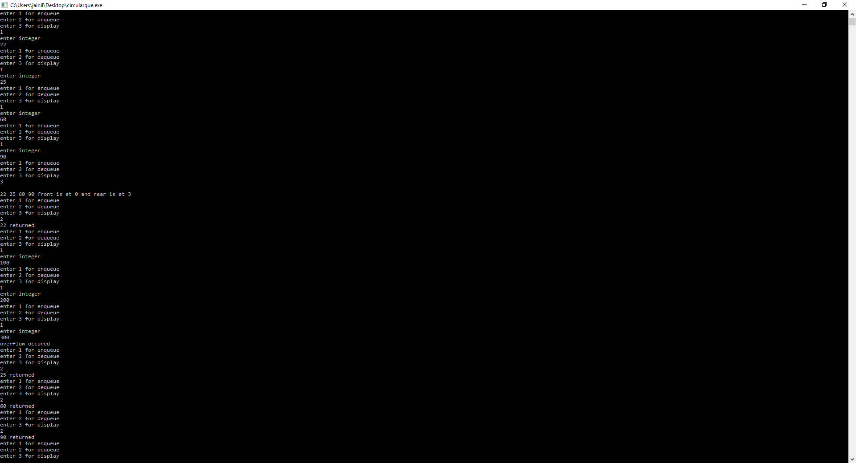  6.1 Write and implement an algorithm called stackToQueue that creates a queue from stack. After the queue has been created, the top of the stack should be the front of the queue and the base of the stack should be the rear of the queue. At the end of the algorithm, stack should be empty.  #include<iostream>  #include <sstream>  #include<string>  #include<math.h>  #include<stdio.h>  #include<stack>  using namespace std;  class cirqularqueue  {  public:  int f=-1;  int r=-1;  int a[5];  void anque(int x)  {  if((f==0&&r==4)||f==(r+1))  {  cout<<"overflow occured \n";  }  else if(f==-1)  {  f++;  r++;  a[r]=x;  }  else if(r==4&&f!=0)  {  r=0;  a[r]=x;  }  else{  r++;  a[r]=x;}  }  int dequee()  {  if((f>r)&&f==4)  {  f=0;  }  if(f==r)  {  int p=f;  f=-1;  r=-1;  return(a[p]);  }  else  {  f++;  return a[f-1];  }  if(f==-1&&r==-1)  {  cout<<"underflow occured \n";  return(0);  }  }  void display()  {  int i;  printf("\n");  if (f> r)  {  for (i = f; i < 5; i++)  {  printf("%d ", a[i]);  }  for (i = 0; i <= r; i++)  printf("%d ", a[i]);  }  else  {  for (i = f; i <= r; i++)  printf("%d ", a[i]);  }  cout<<"front is at "<<f<<" and rear is at "<<r<<"\n";  }  }qq;  int main()  {  stack<int> s;  for(int i=0;i<5;i++)  s.push(i);  while(!s.empty())  {  qq.anque(s.top());  s.pop();  }  qq.display();  }  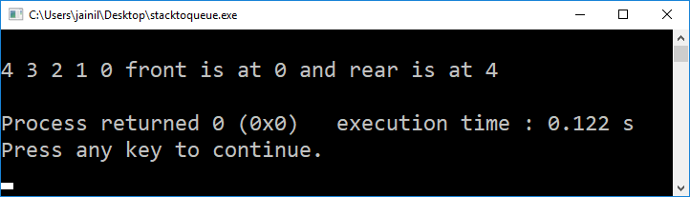  PRACTICAL 7  Implement a city database using unordered lists. Each database record contains the name of the city (a string of arbitrary length) and the coordinates of the city expressed as integer x and y coordinates. Your database should allow records to be inserted, deleted by name or coordinate, and searched by name or coordinate. Another operation that should be supported is to print all records. Implement the database using linked list implementation.  #include <cstdlib>  #include<vector>  #include<iostream>  #include<fstream>  #include<cstdio>  #include<conio.h>  #include<cmath>  #include<cstring>  #include<iomanip>  #include <complex>  #include<dos.h>  #include<algorithm>  #include<ctime>  using namespace std;  struct node  {  string cityname;  int x;  int y;  struct node * ptr;  }*start;  void insertlast()  {  struct node* nn =new node();  cout<<"enter city name:";  cin>>nn->cityname;  cout<<"enter x coordinate:";  cin>>nn->x;  cout<<"enter y coordinate:";  cin>>nn->y;  nn->ptr=NULL;  if(start==NULL)  {  start=nn;  }  else{  struct node* temp;  temp=start;  while(temp->ptr!=NULL)  {  temp=temp->ptr;  }  temp->ptr=nn;  }  }  bool searchbycityname(string c)  {  struct node* temp;  temp=start;  while(true)  {  string data;  data=temp->cityname;  if(data==c)  {  return true;  }  if(temp->ptr==NULL)  {  break;  }  temp=temp->ptr;  }  return false;  }  bool searchbyxycoordinate(int c,int d)  {  struct node* temp;  temp=start;  while(true)  {  int datax;  datax=temp->x;  int datay;  datay=temp->y;  if(datax==c&&datay==d)  {  cout<<"city name is: "<<temp->cityname;  return true;  }  if(temp->ptr==NULL)  {  break;  }  temp=temp->ptr;  }  return false;  }  void deletevbycityname(string s)  {  int i=0;bool flag=false;int foundindex;  struct node* temp1;  temp1=start;  while(true)  {  i++;  string data;  data=temp1->cityname;  if(data==s)  {  foundindex=i;  flag=true;  break;  }  if(temp1->ptr==NULL)  {  break;  }  temp1=temp1->ptr;  }  if(flag==false){cout<<"not found";  return;}  struct node* temp;  temp=start;  for(int k=0;k<i-2;k++)  {  temp=temp->ptr;  }  struct node* temp2=temp->ptr;  temp->ptr=temp->ptr->ptr;  free(temp2);  }  void deletevbycoordinate(int a,int b)  {  int i=0;bool flag=false;int foundindex;  struct node* temp1;  temp1=start;  while(true)  {  i++;  int datax;int datay;  datax=temp1->x;  datay=temp1->y;  if(datax==a&&datay==b)  {  foundindex=i;  flag=true;  break;  }  if(temp1->ptr==NULL)  {  break;  }  temp1=temp1->ptr;  }  if(flag==false){cout<<"not found";  return;}  struct node* temp;  temp=start;  for(int k=0;k<i-2;k++)  {  temp=temp->ptr;  }  struct node* temp2=temp->ptr;  temp->ptr=temp->ptr->ptr;  free(temp2);  }  void display()  {  if(start==NULL)  {  cout<<"empty list\n";  }  else{  struct node* temp;  temp=start;  while(temp!=NULL)  {  cout<<temp->cityname<<" "<<temp->x <<" "<<temp->y<<" -> ";  temp=temp->ptr;  }  }  }  int main()  {  int choice;  while(true)  {  cout<<"\n1 enter data of city\n";  cout<<"2 search by city name\n";  cout<<"3 search by coordinate\n";  cout<<"4 delete by city name\n";  cout<<"5 delete by coordinate\n";  cout<<"6 display list";  cin>>choice;  if(choice==1)  {  insertlast();  }  else if(choice==2)  {  string cityn;  cout<<"enter city name\n";  cin>>cityn;  if(searchbycityname(cityn))  {  cout<<"found\n";  }  else  {  cout<<"not found\n";  }  }  else if(choice==3)  {  int cityx;  cout<<"enter city x coordinate\n";  cin>>cityx;  int cityy;  cout<<"enter city y coordinate\n";  cin>>cityy;  if(searchbyxycoordinate(cityx,cityy))  {  cout<<"found\n";  }  else  {  cout<<"not found\n";  }  }  else if(choice==4)  {  string cityn;  cout<<"enter city name\n";  cin>>cityn;  deletevbycityname(cityn);  }  else if(choice==5)  {  int cityx;  cout<<"enter city x coordinate\n";  cin>>cityx;  int cityy;  cout<<"enter city y coordinate\n";  cin>>cityy;  deletevbycoordinate(cityx,cityy);  }  else if(choice==6)  {  display();  }  }  }  Output:  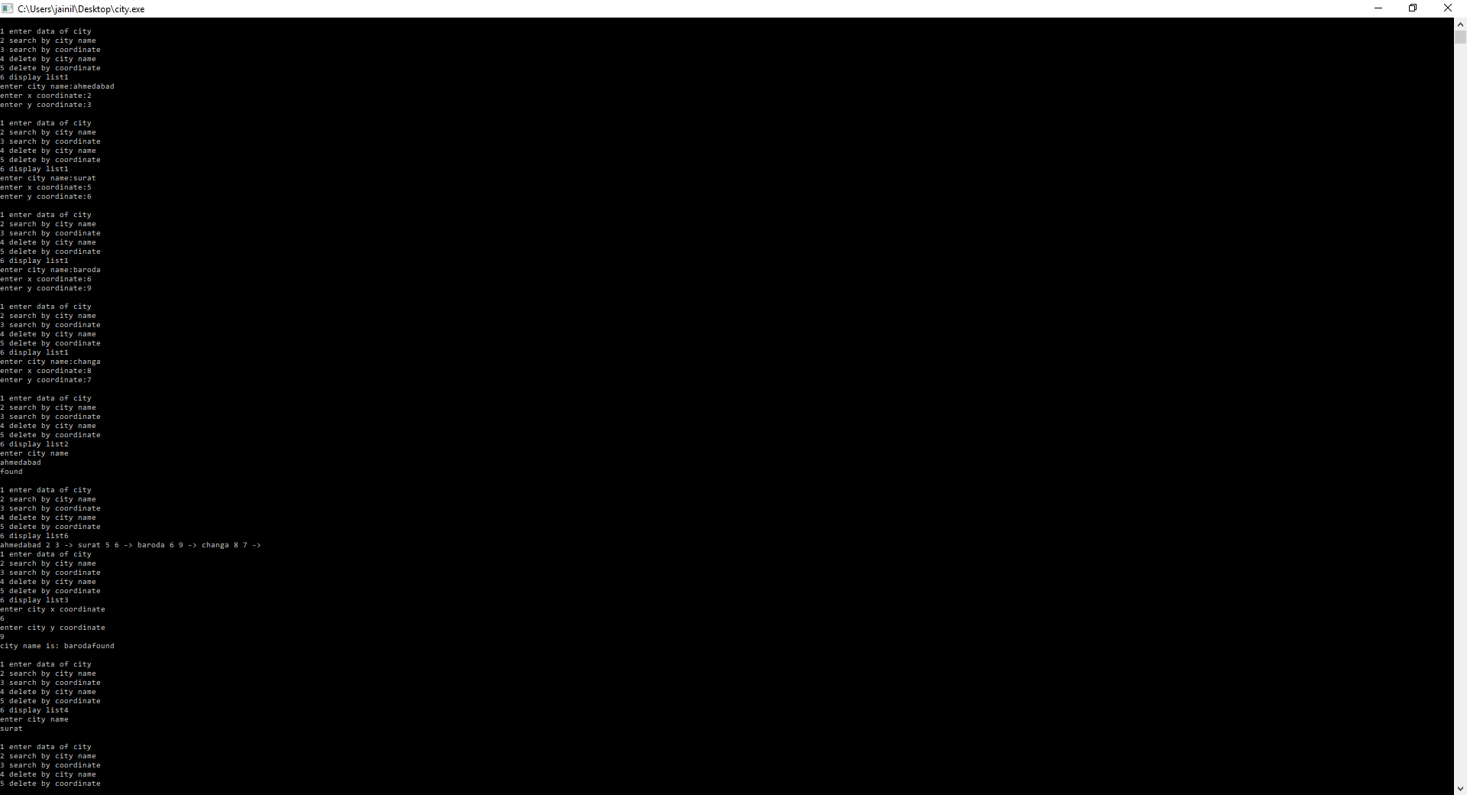  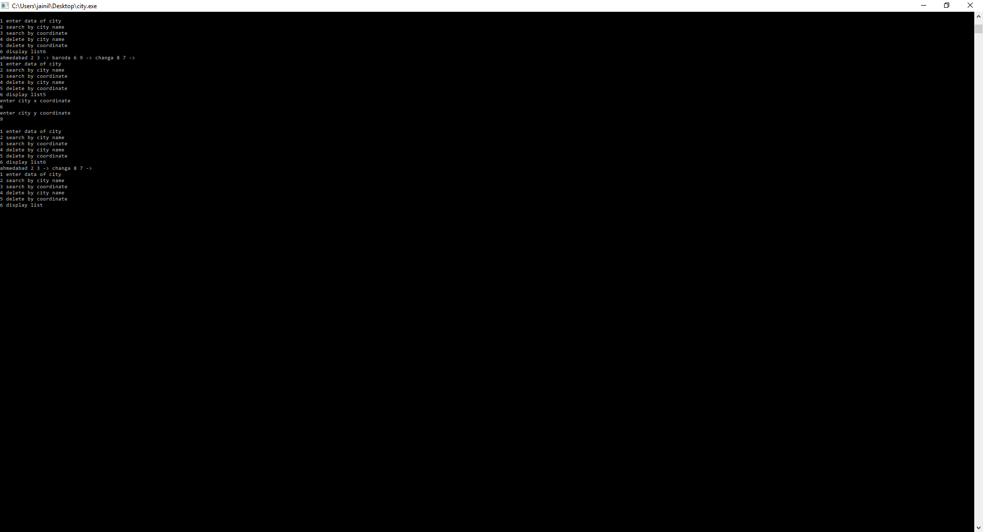  PRACTICAL 8  Write a program to implement Doubly Linked List with insert and delete operations.  #include <cstdlib>  #include<vector>  #include<iostream>  #include<fstream>  #include<cstdio>  #include<conio.h>  #include<cmath>  #include<cstring>  #include<iomanip>  #include <complex>  #include<dos.h>  #include<algorithm>  #include<ctime>  using namespace std;  struct node  {  int info;  struct node * ptr;  struct node * pre;  }*start;  node * last;  void insertlast()  {  struct node* nn =new node();  cout<<"enter data:";  cin>>nn->info;  nn->ptr=NULL;  nn->pre=NULL;  if(start==NULL)  {  start=nn;  last=nn;  }  else{  nn->pre=last;  last->ptr=nn;  last=nn;  }  }  void insertbegin()  {  struct node* nn =new node();  cout<<"enter data:";  cin>>nn->info;  nn->ptr=NULL;  nn->pre=NULL;  if(start==NULL)  {  start=nn;  }  else{  nn->ptr=start;  start->pre=nn;  start=nn;  }  }  void insertmiddle(int i)  {  struct node* nn =new node();  cout<<"enter data:";  cin>>nn->info;  nn->ptr=NULL;  nn->pre=NULL;  struct node* temp;  temp=start;  for(int j=0;j<i-2;j++)  {  temp=temp->ptr;  }  nn->ptr=temp->ptr;  nn->pre=temp;  temp->ptr->pre=nn;  temp->ptr=nn;  }  void deletebegin()  {  if(start==NULL)  {  cout<<"list is empty";  }  else{  node* temp=start;  start=start->ptr;  free(temp);  }  }  void deletelast()  {  if(start==NULL)  {  cout<<"list is empty\n";  }  else{  node * temp = last;  last->pre->ptr=NULL;  last=last->pre;  free(temp);  }  }  void deletemiddle(int i)  {  struct node* temp;  temp=start;  for(int j=0;j<i-2;j++)  {  temp=temp->ptr;  }  struct node* temp2=temp->ptr;  temp->ptr->ptr->pre=temp;  temp->ptr=temp->ptr->ptr;  free(temp2);  }  void display()  {  if(start==NULL)  {  cout<<"empty list\n";  }  else{  struct node* temp;  temp=start;  while(temp!=NULL)  {  cout<<temp->info<<" -> ";  temp=temp->ptr;  }  }  }  int main()  {  int choice;  while(true)  {  cout<<"\nenter 1 for insert at last";  cout<<"\nenter 2 for display";  cout<<"\nenter 3 for insert at begin";  cout<<"\nenter 4 for delete at begin";  cout<<"\nenter 5 for delete at end";  cout<<"\nenter 6 for insert at middle";  cout<<"\nenter 7 for delete at middle\n";  cin>>choice;  if(choice==1)  {  insertlast();  }  if(choice==2)  {  display();  }  if(choice==3)  {  insertbegin();  }  if(choice==6)  {  int lo;  cout<<"enter location:";  cin>>lo;  insertmiddle(lo);  }  if(choice==7)  {  int lo;  cout<<"enter location:";  cin>>lo;  deletemiddle(lo);  }  if(choice==4)  {  deletebegin();  }  if(choice==5)  {  deletelast();  }  }  }  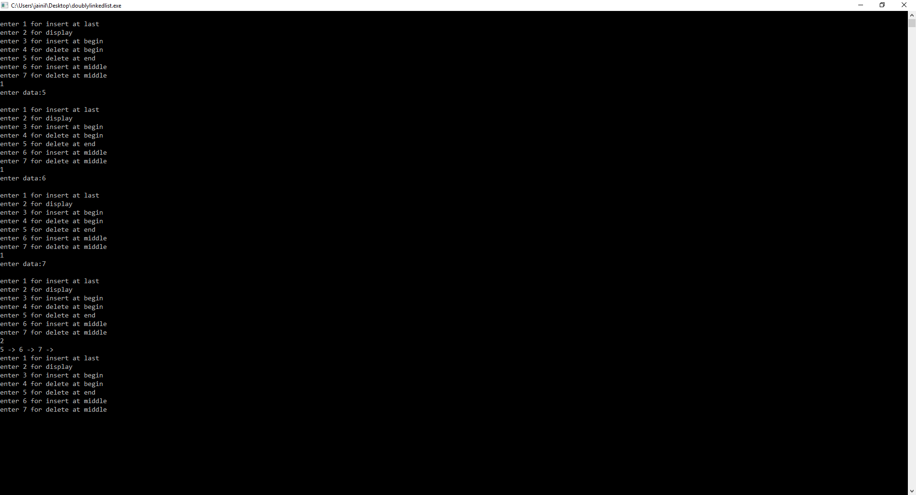  8.1Implement a program to create a movie list. User should be able to insert, delete and search for a particular movie. Print the entire movie list. Also, there is a system of displaying the previous and next movie name from the current movie. If user presses 0, previous movie name should be displayed, and if user presses 1, next movie name should be displayed.  #include <cstdlib>  #include<vector>  #include<iostream>  #include<fstream>  #include<cstdio>  #include<conio.h>  #include<cmath>  #include<cstring>  #include<iomanip>  #include <complex>  #include<dos.h>  #include<algorithm>  #include<ctime>  using namespace std;  struct node  {  string info;  struct node * ptr;  struct node * pre;  }*start;  node * last;  void insertlast()  {  struct node* nn =new node();  cout<<"enter data:";  cin>>nn->info;  nn->ptr=NULL;  nn->pre=NULL;  if(start==NULL)  {  start=nn;  last=nn;  }  else{  nn->pre=last;  last->ptr=nn;  last=nn;  }  }  void insertbegin()  {  struct node* nn =new node();  cout<<"enter data:";  cin>>nn->info;  nn->ptr=NULL;  nn->pre=NULL;  if(start==NULL)  {  start=nn;  }  else{  nn->ptr=start;  start->pre=nn;  start=nn;  }  }  void insertmiddle(int i)  {  struct node* nn =new node();  cout<<"enter data:";  cin>>nn->info;  nn->ptr=NULL;  nn->pre=NULL;  struct node* temp;  temp=start;  for(int j=0;j<i-2;j++)  {  temp=temp->ptr;  }  nn->ptr=temp->ptr;  nn->pre=temp;  temp->ptr->pre=nn;  temp->ptr=nn;  }  void deletebegin()  {  if(start==NULL)  {  cout<<"list is empty";  }  else{  node* temp=start;  start=start->ptr;  free(temp);  }  }  void deletelast()  {  if(start==NULL)  {  cout<<"list is empty\n";  }  else{  node * temp = last;  last->pre->ptr=NULL;  last=last->pre;  free(temp);  }  }  void deletemiddle(int i)  {  struct node* temp;  temp=start;  for(int j=0;j<i-2;j++)  {  temp=temp->ptr;  }  struct node* temp2=temp->ptr;  temp->ptr->ptr->pre=temp;  temp->ptr=temp->ptr->ptr;  free(temp2);  }  int searchl(string s)  {  struct node* temp;  temp=start;  if(start==NULL)  {  cout<<"list is empty\n";  }  int flag=0;  int count=0;  while(temp!=NULL)  {  if(temp->info==s)  {  flag=1;  deletemiddle(count+1);  return count;  }  temp=temp->ptr;  count++;  }  if (flag==1)  {  cout<<"found the movie";  }  else  {  cout<<"movie not found";  }  }  void search(string s)  {  struct node* temp;  temp=start;  if(start==NULL)  {  cout<<"list is empty\n";  }  int flag=0;  while(temp!=NULL)  {  if(temp->info==s)  {  flag=1;  cout<<temp->pre->info<<" "<<temp->info<<" "<<temp->ptr->info;  }  temp=temp->ptr;  }  if (flag==1)  { cout<<"found the movie"; }  else  { cout<<"movie not found"; }  }  void display()  {  if(start==NULL)  {  cout<<"empty list\n";  }  else{  struct node* temp;  temp=start;  while(temp!=NULL)  {  cout<<temp->info<<" -> ";  temp=temp->ptr;  }  }  }  int main()  {  int choice;  cout<<"movie list";  while(true)  {  cout<<"\nenter 1 for insert";  cout<<"\nenter 2 for display full list";  cout<<"\nenter 3 for search";  cout<<"\nenter 4 for delect movie";  cout<<"\nenter 7 for delete at middle\n";  cin>>choice;  if(choice==1)  {  insertlast();  }  if(choice==2)  {  display();  }  if(choice==3)  {  string ss;  cout<<"enter movie to search";  cin>>ss;  search(ss);  }  if(choice==4)  {  string ss;  cout<<"enter movie to delete";  cin>>ss;  cout<<searchl(ss);}}}  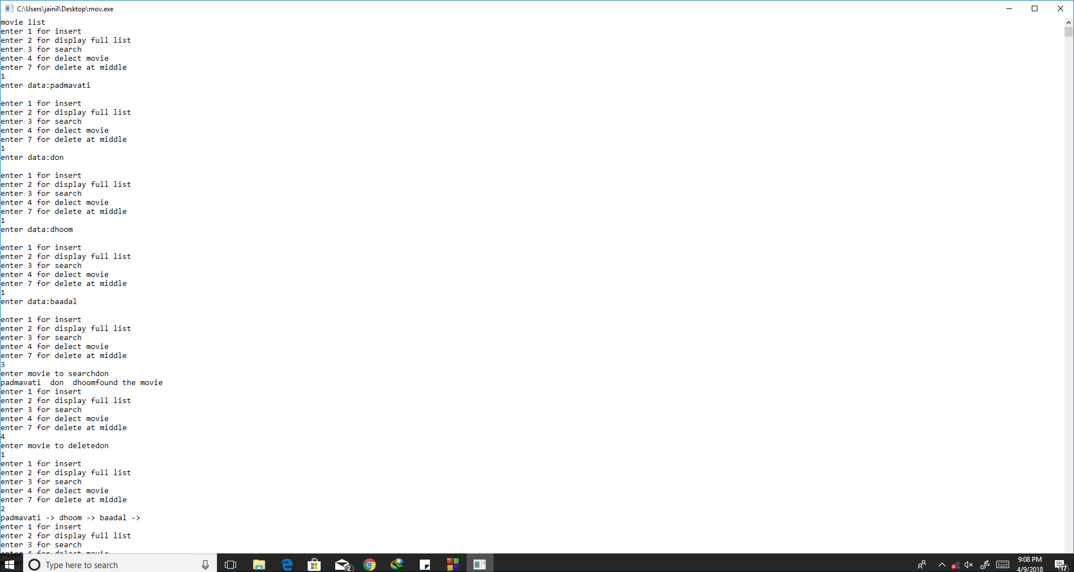  PRACTICAL 9  Implement a program that creates Binary Search Tree and display it. Search particular element in BST. Also implement various Tree traversal techniques.  #include<iostream>  #include<queue>  using namespace std;  struct node  {  node* left;  int data;  node* right;  };  node* root;  void insert(node** root,int data)  {  if(*root==NULL)  {  *root=new node();  (*root)->data=data;  (*root)->left=NULL;  (*root)->right=NULL;  }  else if(data<=(*root)->data)  {  insert(&(*root)->left,data);  }  else  {  insert(&(*root)->right,data);  }  }  void lror(node* root)  {  if(root==NULL)  {  return;  }  lror(root->left);  cout<<root->data<<" ";  lror(root->right);  }  void rolr(node* root)  {  if(root==NULL)  {  return;  }  cout<<root->data<<" ";  lror(root->left);  lror(root->right);  }  void lrro(node* root)  {  if(root==NULL)  {  return;  }  lror(root->left);  lror(root->right);  cout<<root->data<<" ";  }  bool search(node* root,int data)  {  if(root==NULL)  return false;  else if(root->data==data)  {  return true;  }  else if(root->data<data)  {  return search(root->right,data);  }  else {return search(root->left,data); }  }  node* FindMin(node* root)  {  while(root->left != NULL) root = root->left;  return root;  }  // Function to search a delete a value from tree.  struct node* Delete(struct node *root, int data) {  if(root == NULL) return root;  else if(data < root->data) root->left = Delete(root->left,data);  else if (data > root->data) root->right = Delete(root->right,data);  // Wohoo... I found you, Get ready to be deleted  else {  // Case 1: No child  if(root->left == NULL && root->right == NULL) {  delete root;  root = NULL;  }  //Case 2: One child  else if(root->left == NULL) {  struct node *temp = root;  root = root->right;  delete temp;  }  else if(root->right == NULL) {  struct node *temp = root;  root = root->left;  delete temp;  }  // case 3: 2 children  else {  struct node *temp = FindMin(root->right);  root->data = temp->data;  root->right = Delete(root->right,temp->data);  }  }  return root;  }  void LevelOrder(node *root) {  if(root == NULL) return;  queue<node*> Q;  Q.push(root);  //while there is at least one discovered node  while(!Q.empty()) {  node* current = Q.front();  Q.pop(); // removing the element at front  cout<<current->data<<" ";  if(current->left != NULL) Q.push(current->left);  if(current->right != NULL) Q.push(current->right);  }  }  int main()  {  int data;  int choice;  while(true){  cout<<"\n1 insert data in binary tree\n";  cout<<"2 inorder display\n";  cout<<"3 preprder display\n";  cout<<"4 postorder display\n";  cout<<"5 search element\n";  cout<<"6 delete element\n";  cout<<"7 level order display\n";  cin>>choice;  if(choice==1)  {  cout<<"enter data to be inserted\n";  cin>>data;  insert(&root,data);  }  else if(choice==2)  {  lror(root);  }  else if(choice==3)  {  rolr(root);  }  else if(choice==4)  {  lrro(root);  }  else if(choice==5)  {  cout<<"enter data to be searched\n";  cin>>data;  if(search(root,data))  {  cout<<"data is found\n";  }  else  {  cout<<"data is not found\n";  }  }  else if(choice==6)  {  cout<<"enter data to be deleted\n";  cin>>data;  root=Delete(root,data);  }  else if(choice==7)  {  LevelOrder(root);  }}  }  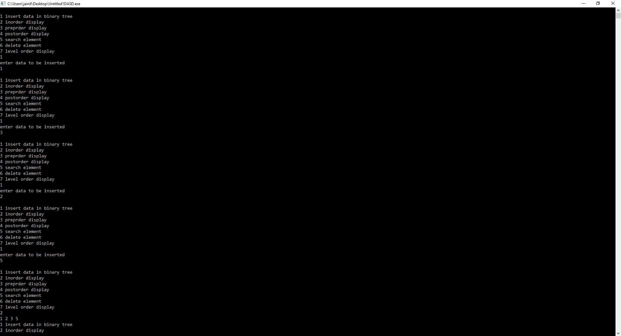  Write a recursive function that returns a count of the number of leaf nodes in a binary tree.  #include<iostream>  #include<queue>  using namespace std;  struct node  {  node* left;  int data;  node* right;  };  node* root;  int count;  void insert(node** root,int data)  {  if(*root==NULL)  {  *root=new node();  (*root)->data=data;  (*root)->left=NULL;  (*root)->right=NULL;  }  else if(data<=(*root)->data)  {  insert(&(*root)->left,data);  }  else  {  insert(&(*root)->right,data);  }  }  void lror(node* root)  {  if(root==NULL)  {  return;  }  lror(root->left);  if(root->left==NULL&&root->right==NULL)  count++;  lror(root->right);  }  int main()  {  int data;  int choice;  while(true){  cout<<"\n1 insert data in binary tree\n";  cout<<"2 count\n";  cin>>choice;  if(choice==1)  {  cout<<"enter data to be inserted\n";  cin>>data;  insert(&root,data);  }  else if(choice==2)  {  lror(root);  cout<<"count of leaf nodes="<<count;  count=0;  }  }  }  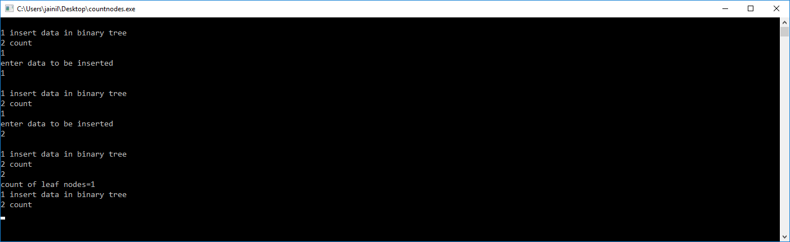  PRACTICAL 10  Write a program that enters vertices, edges of a Graph and display sequence of vertices to traverse the graph in Depth First Search method.  #include<iostream>  #include <sstream>  #include<string>  #include<math.h>  using namespace std;  class q  {  public:  int f=-1;  int r=-1;  char a[50]={};  void anque(int x)  {  if(r!=50){  if(f==-1)  {  f=0;  }  r++;  a[r]=x;  }  else  {  cout<<"overflow";  }  }  int dequee()  {  if(f==r+1)  {  f=-1;  r=-1;  return '/';  cout<<"underflow occured";  }  else  {  f++;  return a[f-1];  }  }  bool isempty()  {  if(f==-1&&r==-1)  {  return 1;  }  return 0;  }  bool iscontain(int k)  {  for(int i=f;i<=r;i++)  {  if(a[i]==k)  {  return 1;  }  }  return 0;  }  }qq;  int mark[6];  int adj[6][6]={{0,0,0,1,0,1},{0,0,1,0,0,1},{0,1,0,1,1,0},{1,0,1,0,1,0},{0,0,1,1,0,1},{1,1,0,0,1,0}};  void dfs(int v)  {  mark[v]=1;  cout<<v<<" ";  for(int i=0;i<6;i++)  {  if(adj[v][i]==1&&mark[i]!=1)  {  dfs(i);  }  }  }  int main()  {  int noofvertex=6;  for(int i=0;i<noofvertex;i++)  {  mark[i]=0;  }  cout<<"PRNTING ADJACENCY MATIX YOU HAVE INSERTED";  for(int i=0;i<noofvertex;i++)  {  for(int j=0;j<noofvertex;j++)  {  cout<<adj[i][j]<<" ";  }  cout<<"\n";  }  cout<<"DEPTH FIRST SEARCH IS:";  dfs(0);  }  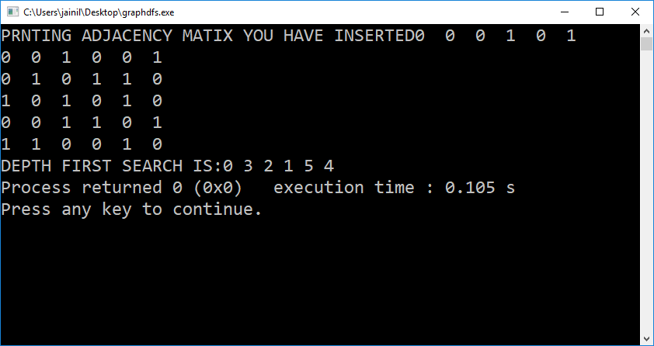  PRACTICAL 11:  AIM: In an array of 20 elements, arrange 15 different values, which are generated randomly. Use hash function to generate key and linear probing to avoid collision. H(x) = (x mod 18) + 2. Write a program to input and display the final values of array.  #include <cstdlib>  #include<vector>  #include<iostream>  #include<fstream>  #include<cstdio>  #include<conio.h>  #include<cmath>  #include<cstring>  #include<iomanip>  #include <complex>  #include<dos.h>  #include<algorithm>  #include<ctime>  using namespace std;  int hashTable[21]={};  int hashTableSize = 21;  int hashFunc(int x)  {  return((x%18)+2);  }  void insert(int s)  {  //Compute the index using the hash function  int index = hashFunc(s);  //Search for an unused slot and if the index will exceed the hashTableSize then roll back  while(hashTable[index] != 0)  index = (index + 1) % hashTableSize;  hashTable[index] = s;  }  void search(int s)  {  //Compute the index using the hash function  int index = hashFunc(s);  //Search for an unused slot and if the index will exceed the hashTableSize then roll back  while(hashTable[index] != s and hashTable[index] != 0)  index = (index + 1) % hashTableSize;  //Check if the element is present in the hash table  if(hashTable[index] == s)  cout << s << " is found!" << endl;  else  cout << s << " is not found!" << endl;  }  int main()  {  int choice;  while(true)  {  cout<<"\nenter 1 for insert in hash table";  cout<<"\nenter 2 for search\n";  int data;  cin>>choice;  if(choice==1)  {  cout<<"enter data:";  cin>>data;  insert(data);  }  if(choice==2)  {  cout<<"enter data to be searched:";  cin>>data;  search(data);  }  }  return 0;  }  